School of Computer Science and Artificial Intelligence

 | LAB ASSIGNMENT - 1
Program | : B. Tech (CSE)
Specialization | :
Course Title | : AI Assisted coding
Course Code | : 23CS002PC304
Semester | : II
Academic Session | : 2025-2026
Name of Student | : K. Deepak
Enrollment No. | : 2303A51T02
Batch No. | : 52
Date | :06-01-2026

Submission Instructions:

(All instructions should be followed strictly to avoid deduction of marks)

- Use the same file to complete the assignment and don’t change the settings.
- Minimum 10 screen shots of your account should be taken to showcase your work.
- File Format:
• Submit your assignment as a PDF document (pdf). Ensure the file is named according to the following convention:
BNo_StudentName_SESD_A1.
Sample: B10_Rohit_22A523421_A1
- Fill all the entries mentioned on top section.
- Mention your AWS Academy Virtual Lab Account details as shown in the next page.
- Don’t write on this page.
- All answers should be answered from next page only.

Submission Starts here

OUTPUT :
SCREENSHOTS:
Task 0: Install and configure GitHub Copilot in VS Code. Take screenshots of
each step.

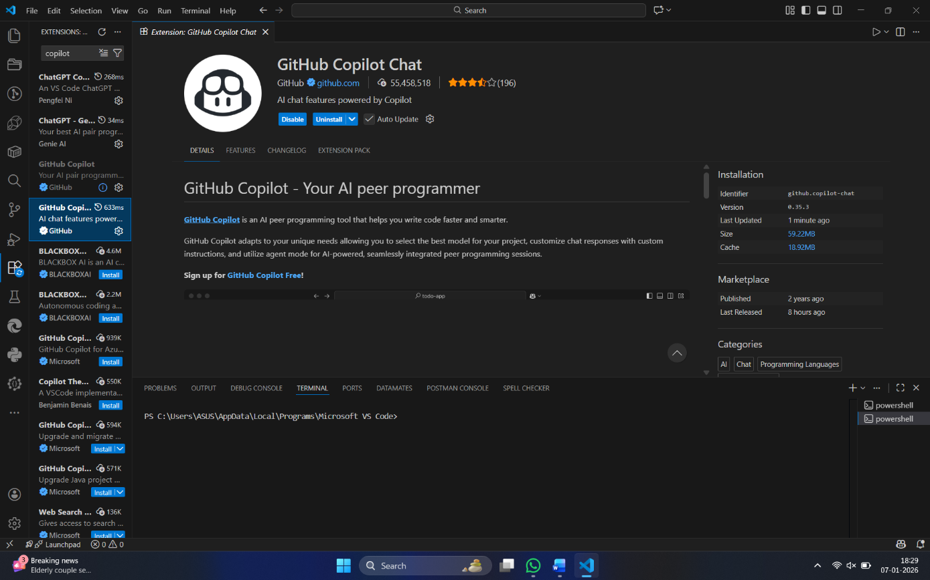

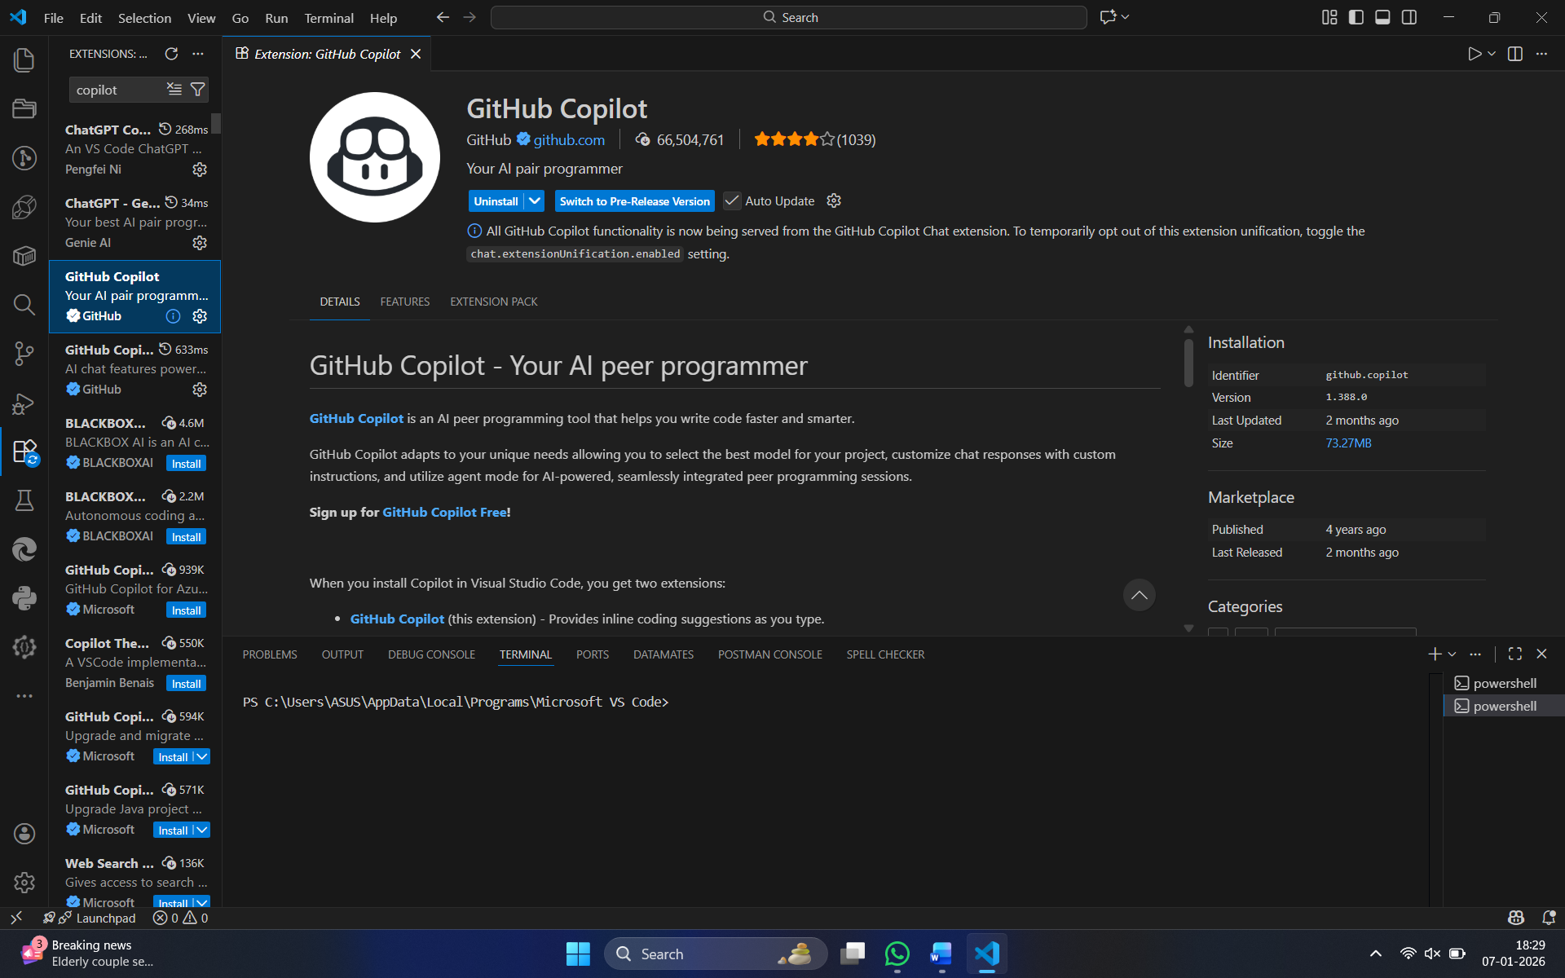


Task1: Task Description
Use GitHub Copilot to generate a Python program that computes a
mathematical product-based value (factorial-like logic) directly in the main
execution flow, without using any user-defined functions.

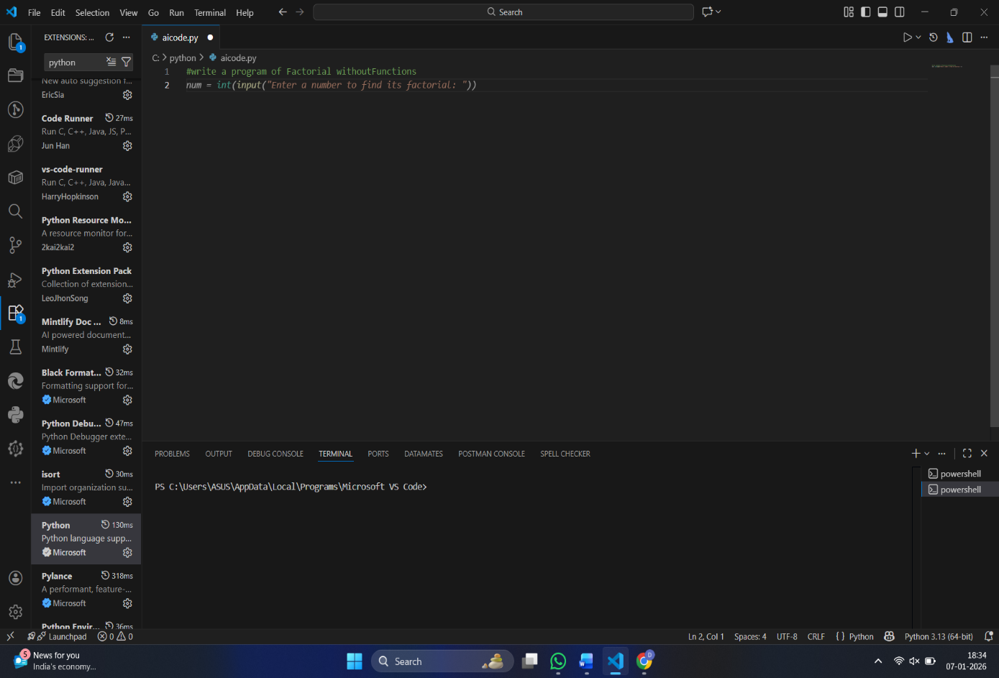
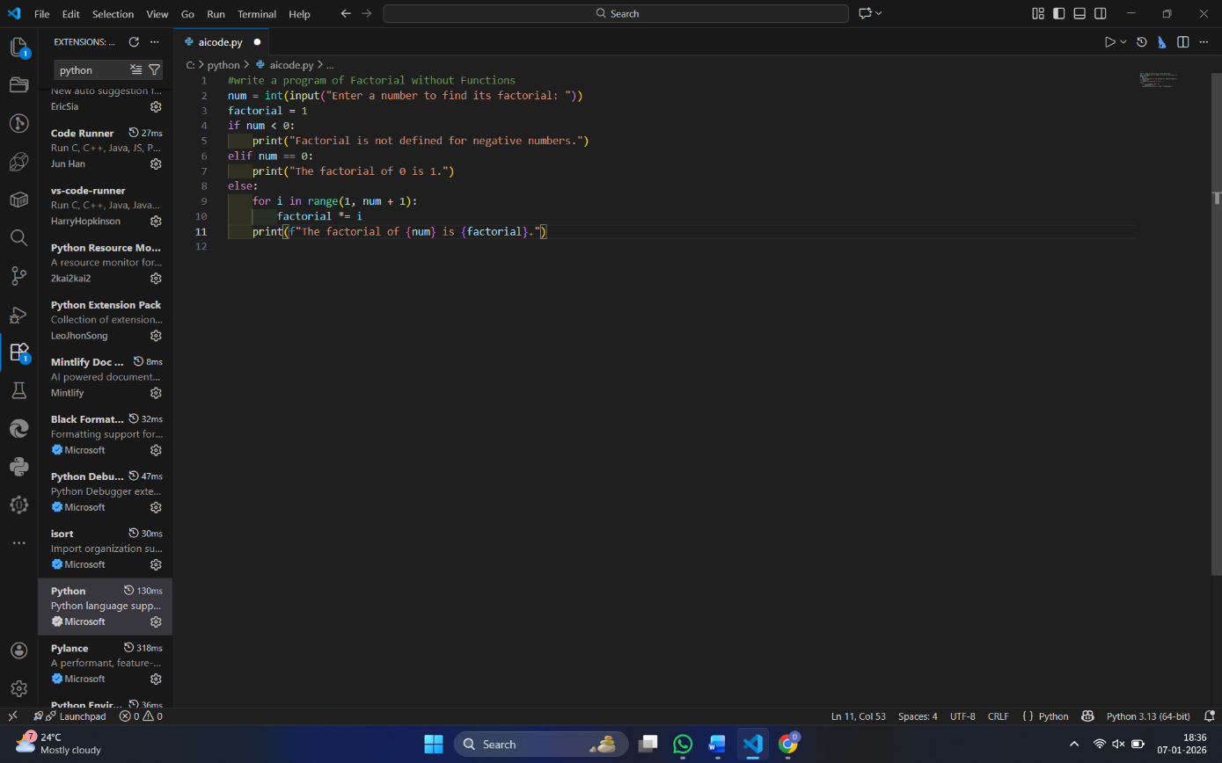
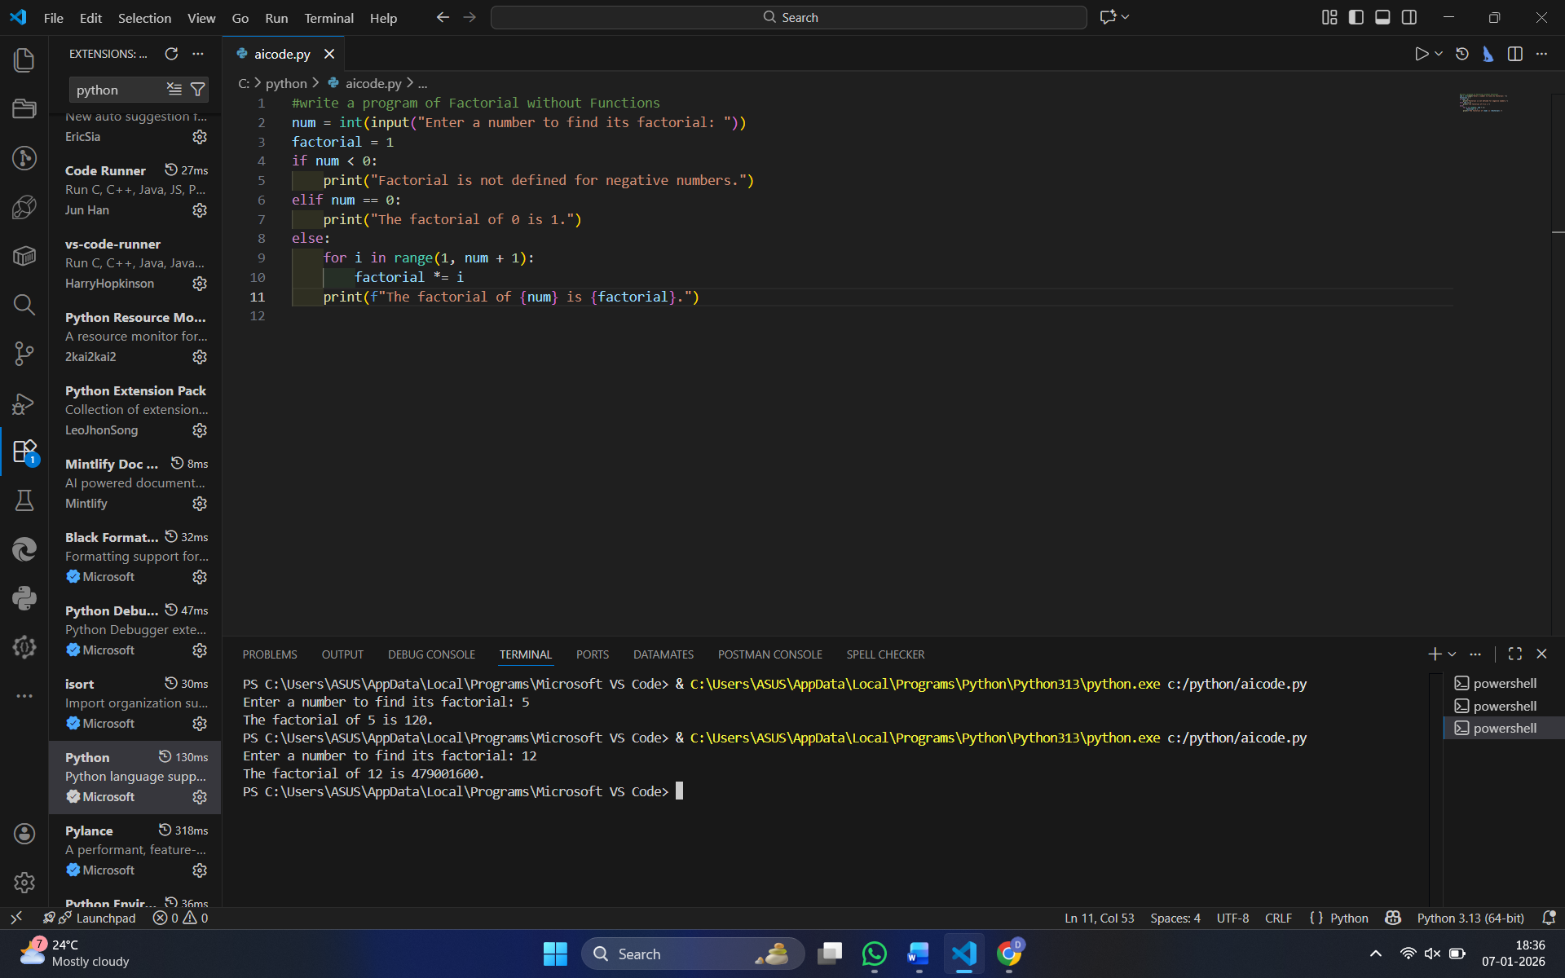

- The Copilot is very helpful because we can generate code by just giving a prompt in Copilot Chat ( ctrl + I )

- The code generated was as requested in the prompt

EXPLANATION :
1️⃣ The program asks the user to enter a number.
2️⃣ It stores the entered value as an integer.
3️⃣ The code calculates the factorial by multiplying numbers from 1 to the given number.
4️⃣ The final multiplied result is stored as the factorial value.
5️⃣ The program prints the factorial of the given number as output.

# TASK - 2

Task Description
Analyze the code generated in Task 1 and use Copilot again to:
- Reduce unnecessary variables
- Improve loop clarity
- Enhance readability and efficiency

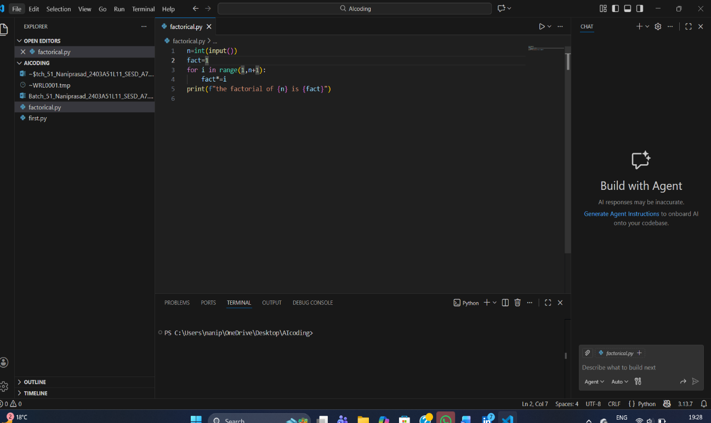

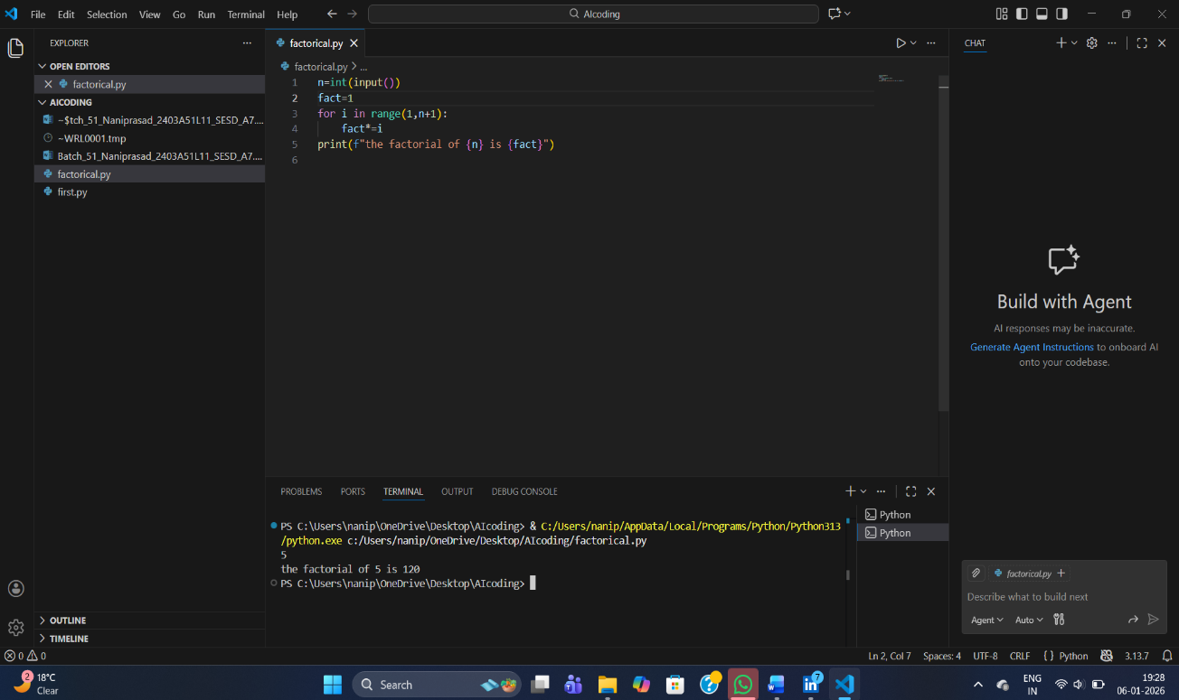

# What was improved?

- Shorter multiplication statement
- factorial = factorial * i → factorial *= i
- Removed unnecessary comment

- The loop logic is self-explanatory, so the comment was removed.

- # Why the new version is better?

- Readability
- *= is clearer and more concise.

- Fewer lines and less clutter make the code easier to read.

- Maintainability
- Cleaner code is easier to modify and debug.
- Reduced redundancy lowers the chance of mistakes.

- Performance
- Performance is effectively the same.

- *= is marginally optimized at the bytecode level, but the difference is negligible.

# Task3
Task Description
Use GitHub Copilot to generate a modular version of the program by:
- Creating a user-defined function
- Calling the function from the main block

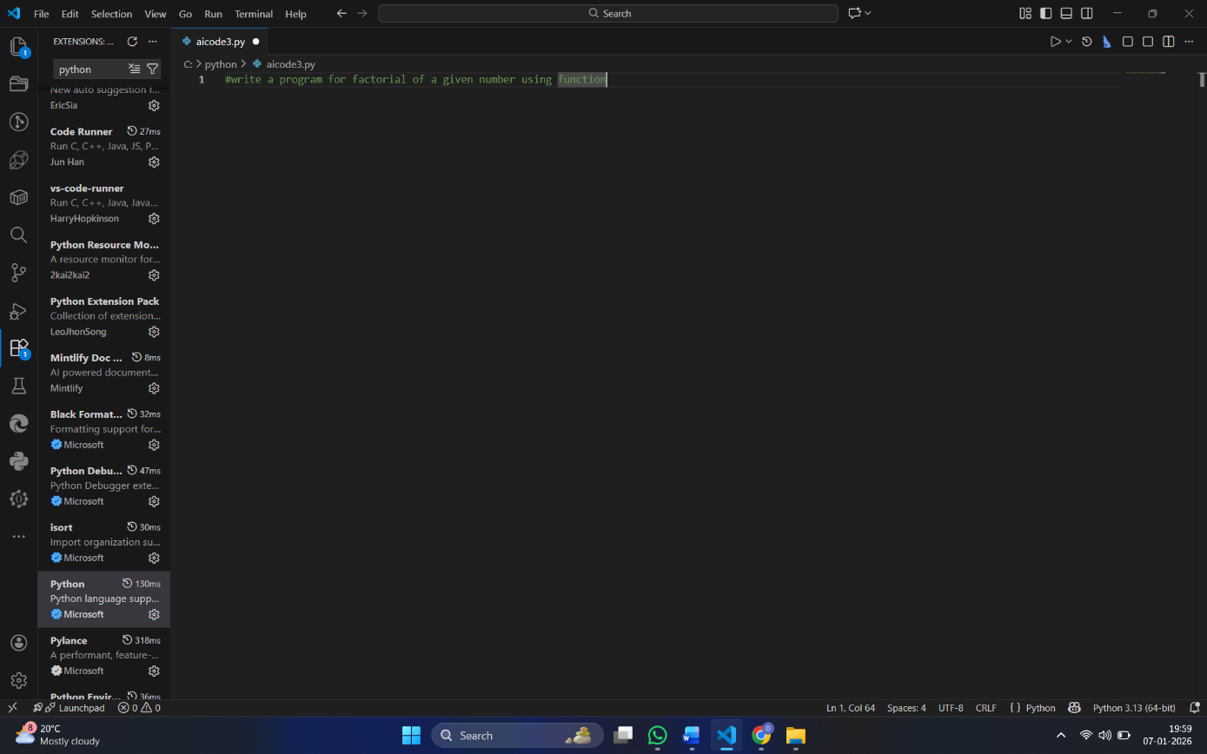

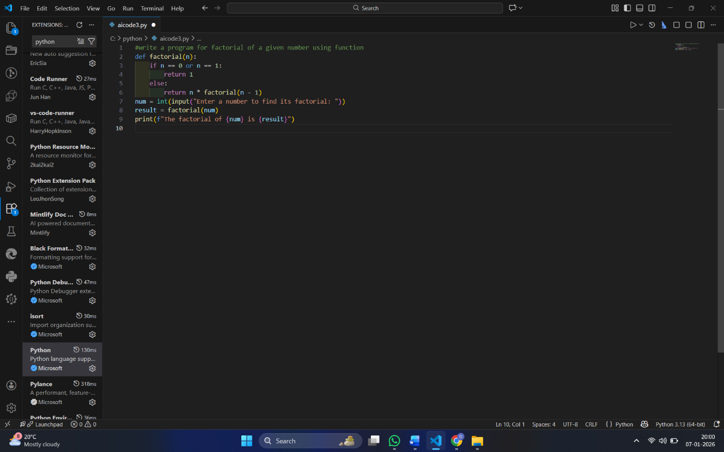

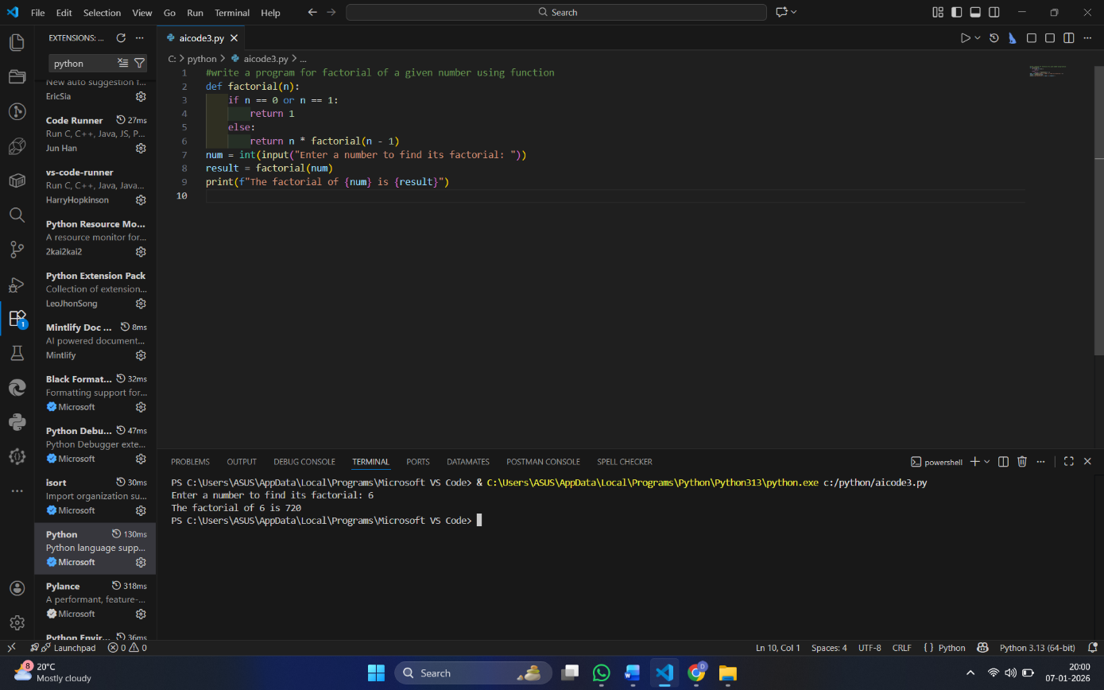

- Modularity improves reusability by:

Allowing the factorial() function to be reused in multiple programs without rewriting code.

Making the program easier to test, update, and debug.

Improving code organization, where logic is separated from input/output handling.

Supporting scalability, as the same function can be extended or integrated into larger projects.

#Task4
Task Description
Compare the non-function and function-based Copilot-generated
programs on the following criteria:
- Logic clarity
- Reusability
- Debugging ease
- Suitability for large projects
- AI dependency risk
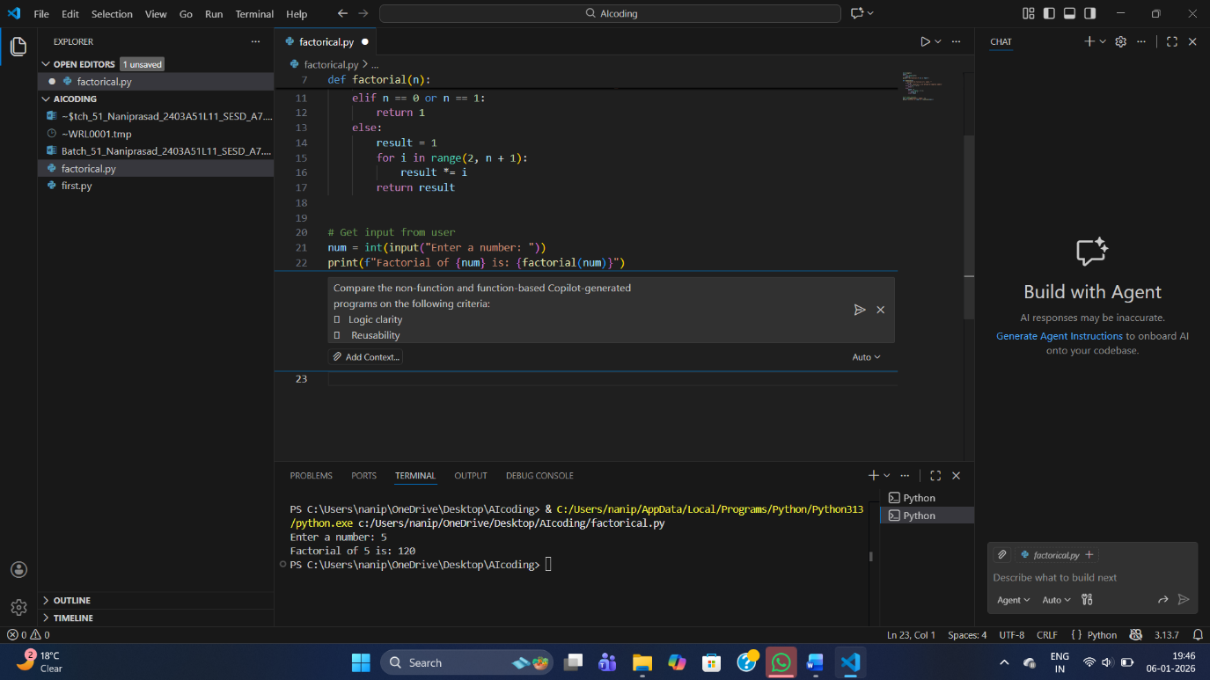

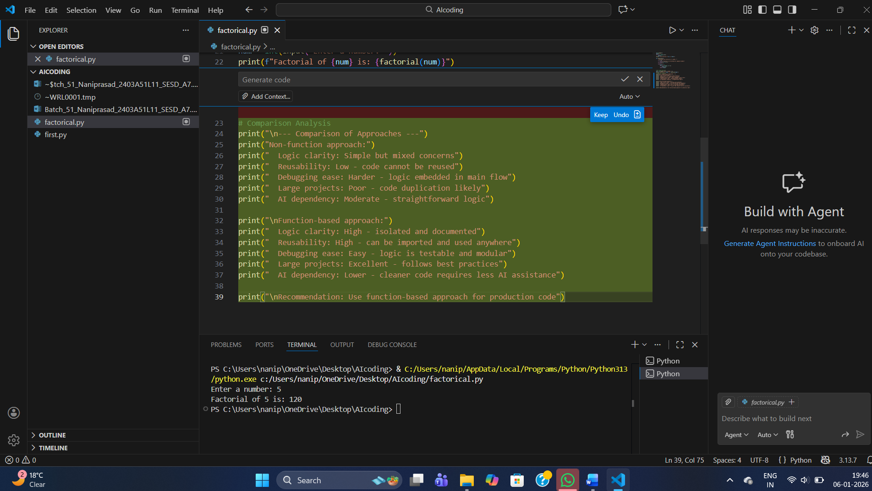

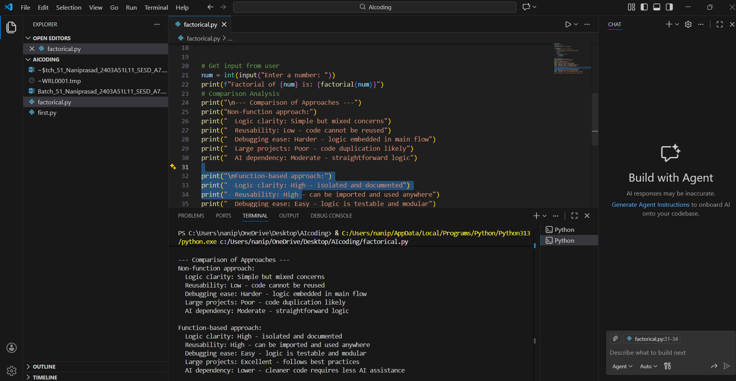

# TASK - 5

Task Description
Prompt Copilot to generate:
An iterative version of the logic
A recursive version of the same logic

